A1. You need VM RIGHT NOW!!
By Javier Pedragosa

Activity 1.
Watch the Tema3.T2 video and install the 2 VMs the speaker explains. The name of the VMs must be yourname_Kali and yourname_Ubuntu.

Add into your pdf a screenshot showing you achieved the challenge (your name must appear on the top of every VM).
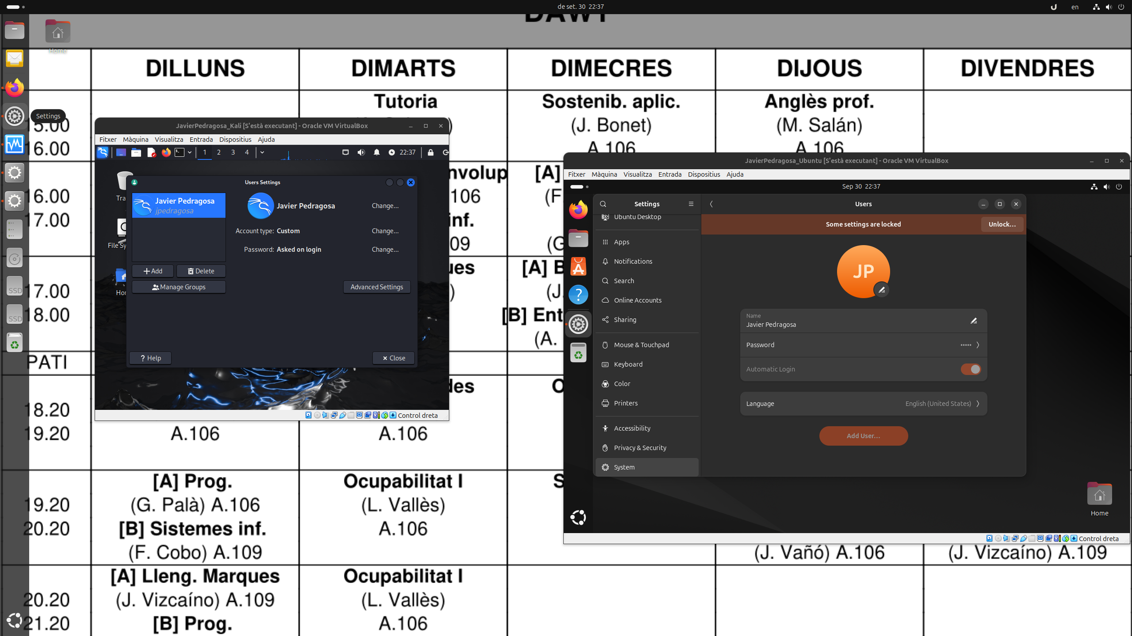Illustration 1: Screenshot of both Kali and Ubuntu running on VirtualBox

Activity 2.
Once you have installed the 2 VMs you have to do the same exercise the speaker explains at creating the snapshot.
Add into your pdf the screenshots showing you achieved the challenge (your name must appear on the top of every VM).
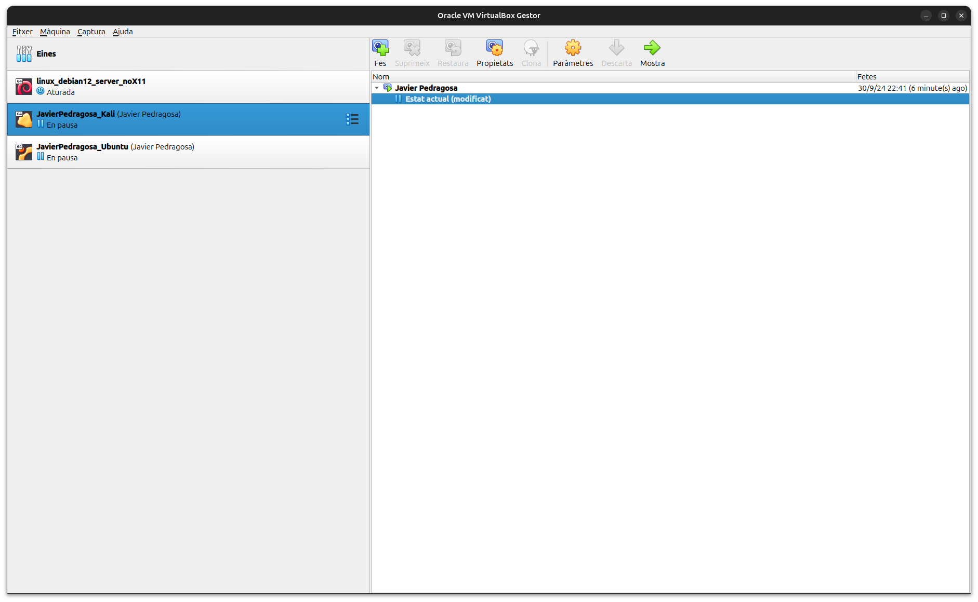Illustration 2: Screenshot of VirtualBox where a snapshot of the Kali virtual machine has been created

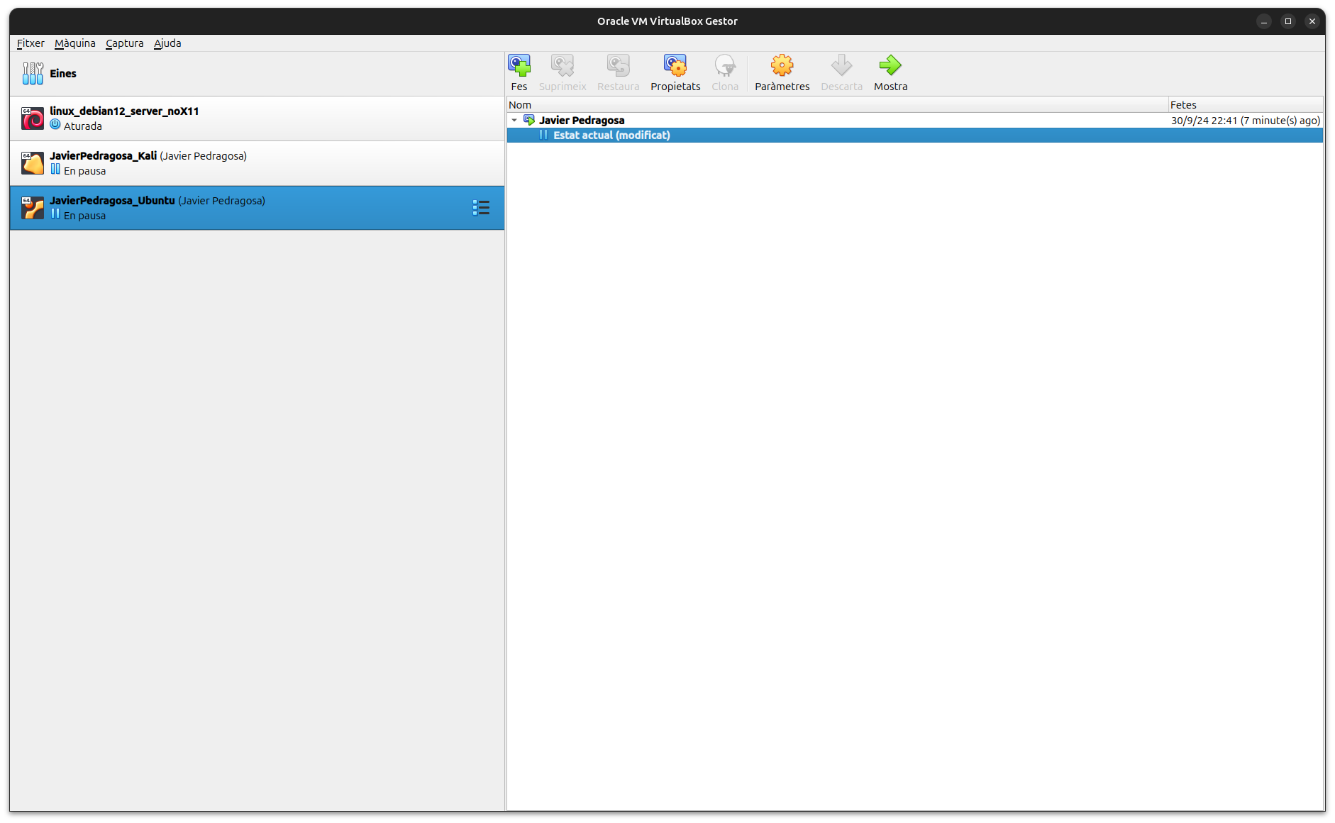Illustration 3: Screenshot of VirtualBox where a snapshot of the Ubuntu virtual machine has been created

Activity 3.
Add into your pdf the key technical information from the video.
0:00 ⏩ Intro
Virtual machines are useful for learning new operative systems and hacking.

0:47 ⏩ What is a Virtual Machine?
A virtual machine is a computer inside a computer, kind of being in the matrix without knowing you are.
If we look inside a computer, we will see the hardware. In order to be able to use the hardware resources, we need to install an operative system in that computer. A virtual machine is a fake computer with its own operative system inside an already existing computer with its own operative system.
All of this is possible thanks to virtualisation.

2:27 ⏩ What is a Hypervisor? (Type 1 vs Type 2)
A Hypervisor is a fancy word for an app you can install in your operative system. One of the more used because it is free is VirtualBox.
This app lets you create virtual machines.

Virtual machines «think» they are a main computer, even though they’re inside a computer.
Virtual machines «borrow» components from the main computer.
Virtualisation has been used by lots of companies.

VirtualBox is a Type 2 Hypervisor, because it is an app that you install on top of an existing operative system.
A Type 1 Hypervisor, such as VMWare, would be installed directly in the hardware, as if it was another operative system.
The main difference between the two would be that a Type 2 Hypervisor has to «ask» the operative system for the computing power or the possible component usage, while a Type 1 Hypervisor has direct and full control over the hardware and how it is used.

A «fake» computer or virtual machine would be a guest computer, while the main computer where the virtual machine is running would be the host computer.

6:18 ⏩ why you NEED a virtual machine
1. If you want to learn hacking you must get a virtual machine.
2. If you want to learn different operative systems.
3. If you want to try risky things in a computer.

7:05 ⏩ TUTORIAL - Virtual Machine Setup
It is easy and free.

You first need a computer with a capable CPU and at least 4GB of RAM would be recommended.
Most operative systems come as x32 or x64 bit versions. To be able to install x64 bit images you need to enable virtualisation in your computer’s BIOS.

7:56 ⏩ *Optional - Support 64bit OS with BIOS change
While most people usually press F12 as fast as they can, entering in the BIOS is as easy as just holding it down while the computer turns on. I just wanted to make that clear.
When in the BIOS, search for Advanced > CPU Configuration > Intel VMX Virtualization Technology and toggle it on. (In case of AMD CPUs, search for AMD V).

9:30 ⏩ Download Kali Linux, Ubuntu (Operating Systems)
Always try to download operative system images in advanced as they are quite heavy, sometimes passing the 5 GB mark.

Make sure the image comes in a .ISO file.

10:30 ⏩ Install Virtual Box (hypervisor)
VirtualBox is free and made by Oracle. It should be quite similar between different operative systems.
When installing it, the default settings should be fine. Also, the installation is not different to the installation of any other apps.

11:56 ⏩ Create a Virtual Machine (Kali Linux)
Click on «New», name the virtual machine, allocate memory size (just enough, because the host computer still needs it to be able to run). Create virtual hard disk, VDI is the default and is good enough, and dinamically allocated, while affects performance a little bit, is more comfortable because it doesn’t take up all the space you allocate to the virtual machine from the host’s storage.

From the virtual machine settings we can tune the amount of CPU cores we are going to use for it.

After running the virtual machine by double-clicking it, the first thing we will be asked to do is to install the operative system, for which we are going to have to find the installation media (.ISO) and follow the steps as we think is good. When in doubt, default is usually good.

When partitions are being created, it seems like we’re going to erase stuff from the host’s storage, but that’s not true because it is just formatting the virtual (fake) hard disk.

18:32 ⏩ Why Virtual Machines are AWESOME!!
The virtual machine is isolated, which is good because we can do anything in it and it will never affect the host computer. That’s why it is such an awesome way to practice hacking.

19:19 ⏩ TIPS and TRICKS (Virtual Box)
When we right click the virtual machine in the VirtualBox menú, we can pause, reset and close the virtual machine.

When we close the virtual machine, we can do so in 3 different ways: we can save state, we can send the stopping signal just like pushing the power button, and finally we can just hard stop it, which would be just like unplugging the computer.

We can also clone the virtual machines, which would make an exact copy of them.
An alternative to cloning, because cloning a whole virtual machine takes up a lot of space, would be to make snapshots, which are like recovery points that we can recall whenever we want. This is useful in case we’re trying risky stuff such as updates.

From settings, in advanced settings, we can set up a shared clipboard, which would be useful so we could copy and paste stuff both from the host and the guest machines.

We can also set up network settings so the virtual machine can connect to the internet, and also we can use these settings to make it more secure in case of an attack.

You can also set up shared folders so you can send files back and forth between the host and guest machines.

